Adapter Pattern
# Source: AI Source: Provided by: [Data Path: Persons Table -> ID Column: 1, Name_En Column: Motasem Essam] -> From: [ChatGPT] on [1/23/2026]
The Adapter Pattern allows incompatible interfaces to work together by converting one interface into another that the client expects.
👉 Think of it like a power plug adapter: it lets a plug fit into a socket with a different shape.

🔑 Key Points
# Source: AI Source: Provided by: [Data Path: Persons Table -> ID Column: 1, Name_En Column: Motasem Essam] -> From: [ChatGPT] on [1/23/2026]
• Converts the interface of a class into another expected by clients
• Promotes reusability of existing code
• Helps integrate legacy or third-party code

❌ Bad Example
# Source: AI Source: Provided by: [Data Path: Persons Table -> ID Column: 1, Name_En Column: Motasem Essam] -> From: [ChatGPT] on [1/23/2026]
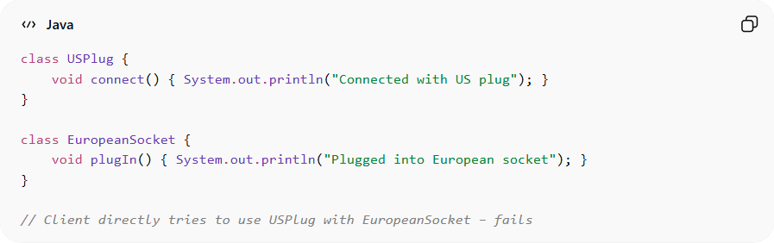
class USPlug {
void connect() { System.out.println("Connected with US plug"); }
}

class EuropeanSocket {
void plugIn() { System.out.println("Plugged into European socket"); }
}

// Client directly tries to use USPlug with EuropeanSocket – fails
Problems:
• Client cannot use incompatible interfaces directly
• Code cannot reuse existing implementations
• Leads to tight coupling or duplicated code

✅ Good Example
# Source: AI Source: Provided by: [Data Path: Persons Table -> ID Column: 1, Name_En Column: Motasem Essam] -> From: [ChatGPT] on [1/23/2026]
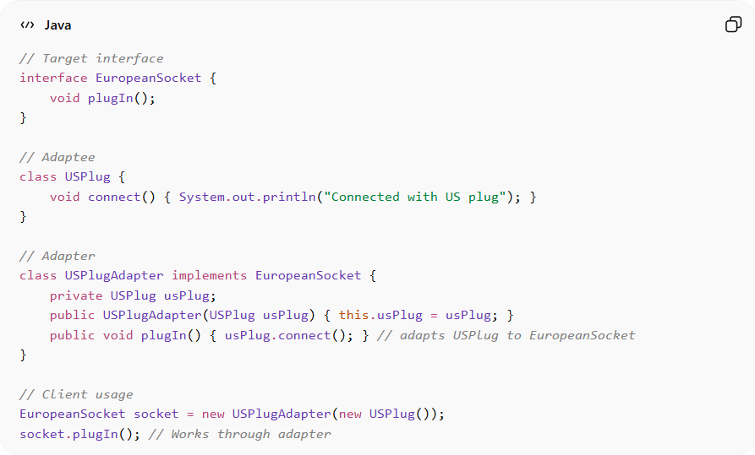
// Target interface
interface EuropeanSocket {
void plugIn();
}

// Adaptee
class USPlug {
void connect() { System.out.println("Connected with US plug"); }
}

// Adapter
class USPlugAdapter implements EuropeanSocket {
private USPlug usPlug;
public USPlugAdapter(USPlug usPlug) { this.usPlug = usPlug; }
public void plugIn() { usPlug.connect(); } // adapts USPlug to EuropeanSocket
}

// Client usage
EuropeanSocket socket = new USPlugAdapter(new USPlug());
socket.plugIn(); // Works through adapter
Benefits:
• Allows reuse of existing classes
• Promotes flexibility and compatibility
• Enables integration of legacy or third-party systems

⚡ Advantages
# Source: AI Source: Provided by: [Data Path: Persons Table -> ID Column: 1, Name_En Column: Motasem Essam] -> From: [ChatGPT] on [1/23/2026]
• Facilitates code reuse
• Decouples client from concrete implementation
• Simplifies integration of incompatible interfaces
• Supports open/closed principle

⚠️ Disadvantages
# Source: AI Source: Provided by: [Data Path: Persons Table -> ID Column: 1, Name_En Column: Motasem Essam] -> From: [ChatGPT] on [1/23/2026]
• Can add extra layers of abstraction
• May increase complexity if many adapters are needed
• Adapter itself can become a maintenance overhead

🛠️ Use Cases
# Source: AI Source: Provided by: [Data Path: Persons Table -> ID Column: 1, Name_En Column: Motasem Essam] -> From: [ChatGPT] on [1/23/2026]
• Legacy system integration – adapt old APIs to new client interfaces
• Third-party library usage – adapt to your application interfaces
• GUI frameworks – connecting incompatible widgets or components
• Hardware/software interfaces – like USB to HDMI adapters in code simulation

